Preparations for the Biosite
Front End Style Guide (Atomic Design)
Atoms(Colors, Typography, Buttons, Links)
- Typography
Heading Font: Sans-serif
Body Font: Sans-serif
Reasoning: Clean, professional, readable

- Color Palette
Primary Color: Deep Navy
Hex: #1F2A44
Use: Header backgrounds, navigation bar, main headings

Secondary Color: Slate Blue-Gray
Hex: #5B6B7A
Use: Subheadings, icons, secondary buttons

Accent Color: Soft Teal
Hex: #3FA7A3
Use: Links, hover states, timeline markers, highlights

Background Color: Off-White
Hex: #F5F7FA
Use: Page background

Text Color: Charcoal
Hex: #2B2B2B
Use: Body text
Supporting Color if needed: Muted Sage Green
Hex: #8FAE9D
Use: Hobby section accents (running / balance theme)

Wireframes
Molecules (Naviation Bar, Image cards, Caption blocks)
Organisms (Hero Section, image grid sections, footer)
Templates (Landing, About, Hobbies)
Landing Page
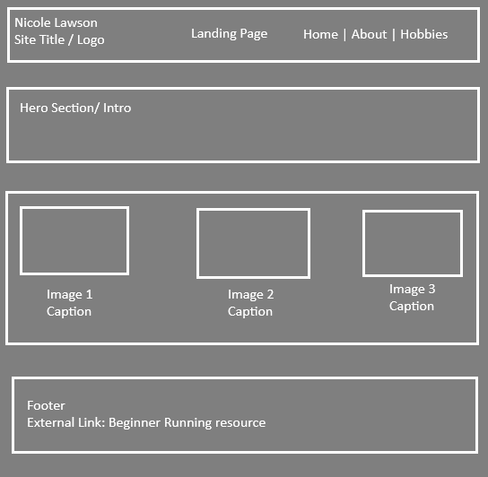

Hobbies
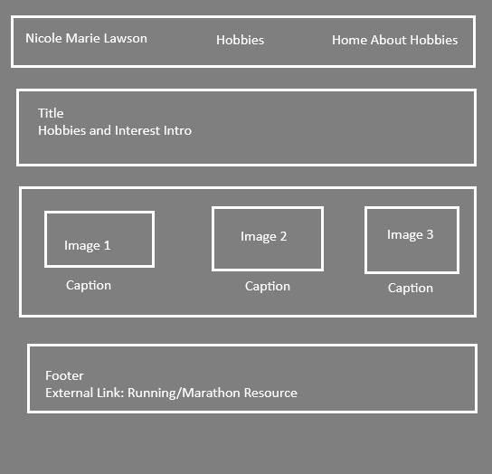

About
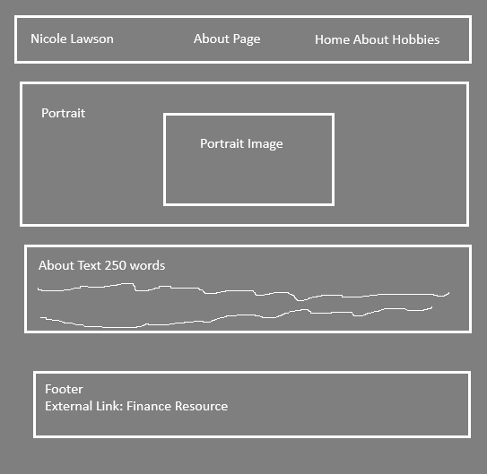
Interview Questions
- How would you describe yourself in three words, and why those three?
  - Analytical, reliable, and determined. I think logically and stay focused on long-term goals.
- What do you do for work?
  - I work as a finance associate, supporting financial analysis, reporting, and decision-making.
- Where did you grow up, and what’s one experience from that time that shaped you?
  - I grew up in the Metro Detroit area. I always enjoyed math and science and that shaped how I think and sparked my interest in finance.
- What’s a challenge you’ve faced that changed how you think or live?
  - Balancing a demanding internship with a full academic course load during my final year of college taught me discipline, prioritization, and how to perform under pressure.
- What is a moment you felt genuinely proud of yourself? What led to it?
  - Earning a full-time finance associate role shortly after graduation. It came from consistent effort, persistence, and learning from strong mentors.
- What values guide your decisions?
  - Discipline, accountability, curiosity, and long-term growth.
- What’s something people often misunderstand about you?
  - Because I’m analytical and reserved, people sometimes assume I’m inflexible, when I’m actually very adaptable once I understand the goal.
- What’s a goal you’re working toward this year? Why does it matter to you?
  - Progressing toward a senior financial analyst role. It matters because it represents trust, expertise, and stability built through high-quality work.
- What hobby do you most enjoy, and how did you get into it?
  - Distance running. I started in high school as a way to manage stress.
- Tell me about a memorable moment connected to your hobby.
  - Completing my first marathon. When I run I feel healthy and on top of my daily routines.

Biography
Nicole Lawson is a finance associate living in Michigan, known for her analytical mindset, reliability, and strong determination. She grew up in the Metro Detroit area, where she developed an early interest in numbers and problem-solving. This natural curiosity, combined with a structured way of thinking, eventually guided her toward a career in corporate finance and financial analysis.

A significant turning point in Nicole’s life occurred during her final year of college, when she balanced a demanding internship alongside a full academic course load. Managing these responsibilities simultaneously required discipline, effective prioritization, and adaptability. The experience strengthened her ability to work under pressure and continues to influence how she approaches professional challenges today. One accomplishment Nicole is especially proud of is earning a full-time finance associate position shortly after graduation. This milestone was achieved through consistent performance, persistence, and guidance from mentors, and it reflects her commitment to long-term professional growth and accountability.

Outside of her primary career responsibilities, Nicole enjoys distance running and casual home cooking. She began running during high school as a way to manage stress and has maintained the habit because it fosters mental resilience and provides structure to her daily routine. A particularly memorable achievement was completing her first marathon, an experience that reinforced her confidence and determination. Running remains an important outlet that helps her maintain balance and manage the demands of daily life.

Looking ahead, Nicole is working toward becoming a senior financial analyst. Her motivation is driven by a desire for stability, excellence, and earning trust through high-quality work. Overall, Nicole’s story is one of persistence, discipline, and steady growth as she continues to build a meaningful and sustainable career.
3 Images(Hobby) with small write-up captions – Hobby Page Caption:
Distance running is important for Nicole’s daily routine. It helps her maintain focus, discipline, and mental resilience. What began as a stress-management outlet in high school has grown into a consistent practice that supports both her physical and mental well-being.
Caption:
Running builds consistency in Nicole’s life and helps her build the discipline and attention to detail she applies to her professional and personal goals.

 Caption:
Running also provides balance and community, reinforcing healthy habits and long-term consistency. Whether training alone or alongside others, this routine supports Nicole’s commitment to maintaining structure and endurance in her everyday life.

3 Images(Goals/Accomplishments) with small write-up captions – Landing 
Caption:
As a finance associate, Nicole supports financial analysis and reporting. Her analytical mindset and attention to detail allow her to translate data into meaningful insights that support long-term organizational goals.
Caption:
Growing up in the Metro Detroit area shaped Nicole’s appreciation for hard work, structure, and long-term growth. The city’s strong professional culture continues to influence her disciplined approach to building a stable and successful career.


Caption:
Nicole is focused on advancing toward a senior financial analyst role by delivering high-quality work and earning trust through consistency and accountability.
Images (Portrait) – About Page 

